## horizontal line



IABC Website Design & Development

12 February, 2021

Yavins’ Team Members:

**Khelan Natha** -

**Dhruv Modi** -

**Krupal Patel** - 200385434

[GitHub](https://github.com/dhruvkmodi/ENSE271_Yavins)

**Course:** ENSE 271

**Professor:** Tim Macaig

Table of Content

**Summarized project background & business need/opportunity** **2**

**Customer Insight** **2**

Northstar 2

Carryover 2

**Project Assumptions** **2**

**Constraints** **2**

**Affinity Diagram** **3**

Empathy Map **4**

# Summarized project background & business need/opportunity

To create a website for IABC Regina, that is easy, simple and efficient for both the user and the employees of IABC Regina. The prime focus over here will be the aesthetics and front-end of the website. We will get the opportunity to create a more user friendly website that will easily guide users.They communicated that it is hard to administer and navigate. This document explains the planning phase of the project and our interpretation of the problem description thus far. In order to complete this project, we organize meetings, discuss ideas and document them to keep track of our progress.

# Customer Insight

### Northstar

Northstar customers are our IABC members who are presenting their ideas to us during the span of the project.

### Carryover

For the part of this project the carryover customers are considered as the members who are a part of the website which include the student members. Mid-level members and the senior level members. As well as other users such as job applicants and job providers,

# Project Assumptions

We will be using the Wordpress and Wordpress tools to create the website. Wordpress is a content management which is open-source and free. We will be only working on the front-end and because of this Wordpress is our ideal choice. It will allow us to use templates and that could help us create the correct website according to what the client wants.

# Constraints

* Working virtually could be difficult for us, communication is less detailed and effective when it is online. Time zones could cause conflict, not all of us are in Saskatchewan.Team work will be less effective within the team. This could impact the efficiency of the project and could cause delays. Within the team we can work together online however, it is not that efficient. Real communication and team work is always more efficient than working online.
* Wordpress, we have a zero to beginner experience with Wordpress and it is a new tool for us. This means we will have to figure out some of the features of Wordpress that will help build the website that the client wants.
* There could be possibilities that the features that the clients want could be a free extension/widget however there could also be possibilities that it is not free. If it is not free then cost could be a constraint and will limit us to only free features. These free features could meet the requirements of the clients however they could also not meet the requirements.
* Team Bond, not all of us will know each other's skills and weaknesses related to this project. While some of our team members know each other personally and could know each other's weakness and skills. Not knowing each other's weakness and skills could impact efficiency in the project and delay a task if the task is assigned to members who are weak at that task. They would need more time. However chances are also that team members with correct skills will meet the correct task. Team Bond could also be a weak cause of online meetings. The team has not met each other physically.
* Team Habits, we all have different styles of doing projects, while some like meeting due dates early others are more comfortable in working till the last day. These internal differentiations could cause conflict among team members and cause delay in completing a task related to the project. These conflicts also cause inefficiencies.

# Affinity Diagram

[Link to Affinity Diagram](https://github.com/dhruvkmodi/ENSE271_Yavins/blob/main/Activity%20%231/Diagrams/Affinity%20Diagram.jpg)

Affinity Diagrams are about ideas, observation, and findings that solve a question/challenge. These ideas, observations, findings are written on a sticky note. The two surface steps of Affinity Diagram are :

1. Write Sticky notes with finding, observation, and ideas
2. Organizing the Sticky notes into groups

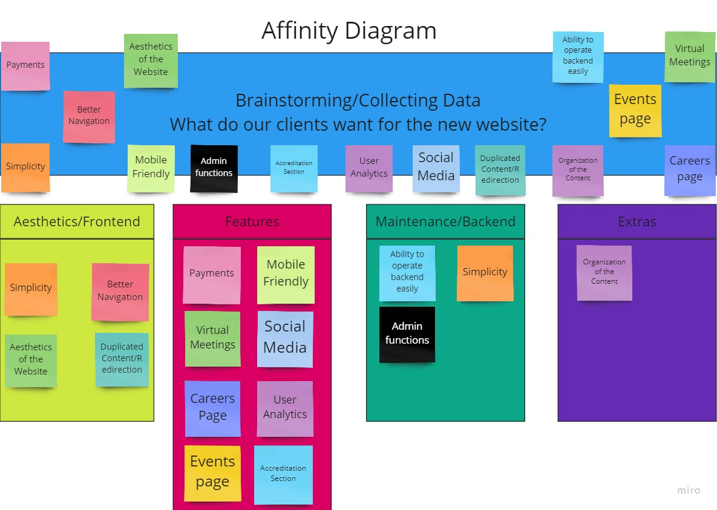

# Empathy Map

[Link to Empathy Map](https://github.com/dhruvkmodi/ENSE271_Yavins/blob/main/Activity%20%231/Diagrams/Empathy%20Map.jpg)

The Empathy map gives us a refined idea of what users want for their project. In addition to that, we also capture what are the feelings of the users, what improvements or ideas they would like us to implement.

**User Story Map**

[**https://landofooo.storiesonboard.com/**](https://landofooo.storiesonboard.com/m/yavins)

Link to User Story Map

